**TERRAFORM CODEPIPELINE**

Steps:

STEP 1: Create a github repo for source code of pipeline.  
 [Navjit-Kaur-TX/AWSCICDIACT (github.com)](https://github.com/Navjit-Kaur-TX/AWSCICDIACT/tree/main)

Step 2: Connect to AWS codestar

1. Go to AWS console -> Developer Tools -> Settings -> Connections -> Create Connection
2. Select GitHub if you are using github otherwise select from other options.
3. Enter connection name
4. Select ‘Install a new app’  
     
   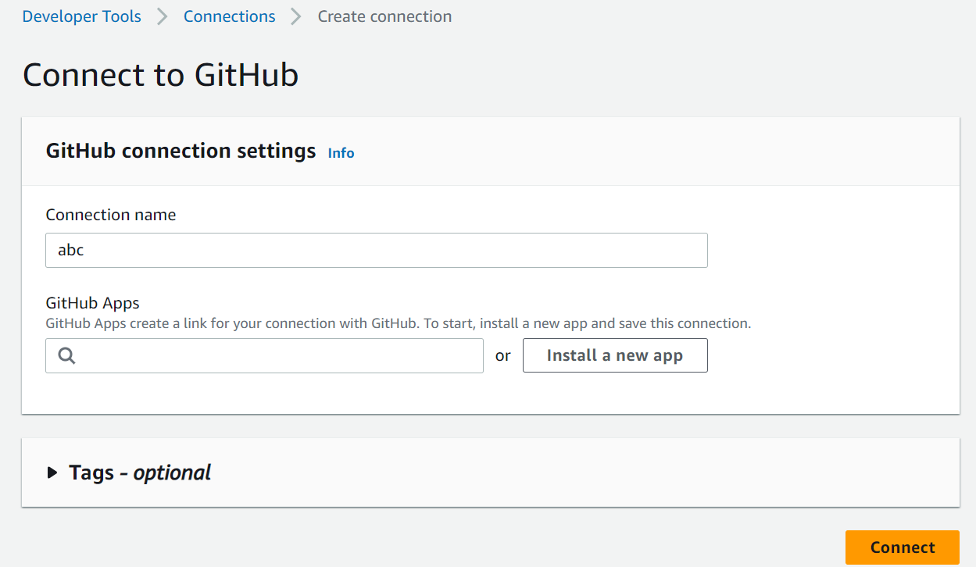
5. It will navigate to a new window, enter github username and password and create connection.

Step 2: Create terraform.tfvars file and store your dockerhub and codestar credentials.  
 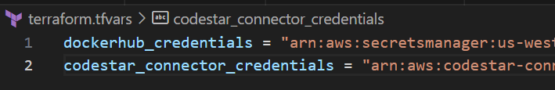

Step 3: Create provider.tf file and add provider and backend info in that.

Step 4: Create variables.tf file

Step 5: Create iam.tf file

File content: [AWSCICDIACT/iam.tf at main · Navjit-Kaur-TX/AWSCICDIACT (github.com)](https://github.com/Navjit-Kaur-TX/AWSCICDIACT/blob/main/iam.tf)

Step 6: create s3.tf file

File content: [AWSCICDIACT/s3.tf at main · Navjit-Kaur-TX/AWSCICDIACT (github.com)](https://github.com/Navjit-Kaur-TX/AWSCICDIACT/blob/main/s3.tf)

Step 7: Create a buildspec folder for codeBuild project and add buildspec-plan and buildspec-apply file in that

File content: [AWSCICDIACT/buildspec at main · Navjit-Kaur-TX/AWSCICDIACT (github.com)](https://github.com/Navjit-Kaur-TX/AWSCICDIACT/tree/main/buildspec)

Step 8: Create pipeline.tf for codePipeline

File Content: [AWSCICDIACT/pipeline.tf at main · Navjit-Kaur-TX/AWSCICDIACT (github.com)](https://github.com/Navjit-Kaur-TX/AWSCICDIACT/blob/main/pipeline.tf)

Step 9: Make sure to have all these files in your github repo otherwise your pipeline build will fail.